A Division of The Axiom Group Inc.  2869 Jolly Road  Okemos, MI 48864 | www.AxiomCopy.com | 517.886.5099  Toll Free 877.886.5090  Fax 517.886.4116


American Transit Insurance Co.
Dept. Claims
1 Metro Tech Center
Brooklyn, NY 11201

RE: Brooks v. Davis, Rodriguez, Aracena's Transport, Inc

Dear Records Custodian,

Enclosed you will find a subpoena requiring you to produce certain records which we believe are in your possession. Please note that as of January 1, 2012 Section 418.853 of the Workers’ Compensation Act no longer requires a magistrate’s signature in order for subpoenas to be valid. On their new form, only the issuing attorney’s signature is required.
Compliance may be met by mailing true and certified copies of the subpoenaed records to the below address. Please send a cover letter on your letterhead reflecting that the materials you have sent are the complete records that you have regarding the above-named individual. Please also complete the certificate on the back side of the subpoena and attach a complete copy of the original records to the subpoena. Please deliver copies of the subpoenaed information on or before the date indicated.
If actual films are requested, we request that you advise if you are providing copies or if you will require those films to be returned to your office once the litigation in this matter has concluded.
If you choose to refuse to comply with this subpoena, you may appear live before the magistrate on or before the date indicated on the subpoena. Failure to comply with the subpoena may result in an adjudication of contempt of court. We, therefore, trust that we will have your cooperation.
Please be advised that the HIPPA Privacy Rule does not apply to entities that are either Worker's Compensation insurers, Worker's Compensation administrative agencies, or employers, 45 CFR 164.512(l). Therefore, a signed release by the patient is not necessary.
If there are any questions, please let us know.
Very truly yours,

Jayashri S. Cuffey
Jayashri S.Cuffey
WAD/ldb

Enclosures

Axiom Requisition Copy Service
2869 Jolly Road, Okemos, Michigan 48864
517.886.5099 – 877.886.5090 toll free – 517.886.4116 facsimile – records@axiomcopy.com

REQUEST FOR RECORDS - ORDER NUMBER 01-28888-001

TO THE CUSTODIAN OF RECORDS Date Sent: November 8, 2026
American Transit Insurance Co.
Dept. Claims
1 Metro Tech Center
Brooklyn, NY 11201
Please find enclosed a request for records of:
Jocelyn Brooks
DOB 03/08/1968 SSN xxx-xx-1286
We are requesting the following:

Entire No-Fault file from 6/29/2012 to present pertaining to Jocelyn Brooks SSN: xxx-xx-1286, DOB: 03/08/1968.

INSTRUCTIONS
- FORWARD INVOICE WITH RECORDS – If fee is greater than $50.00 Pre-approval is required.
- PLEASE DO NOT STAPLE DOCUMENTS.
- Mail, email or fax the records to: Axiom Requisition Copy Service (as agent of Jayashri S. Cuffey, Crisci, Weiser & McCarthy), 2869 Jolly Road, Okemos, MI 48864 – Phone: 517.886.5099 – Fax: (517) 886-4116 – Email: records@axiomcopy.com.
SIGN AND RETURN THIS FORM WITH THE REQUESTED RECORDS
__________________________________________________________
CERTIFICATION OF RECORD SUBMISSION
I certify in response to the request issued to me, that I have submitted a true and complete copy of all requested documents in my control or possession relating to the above person; and that (A) The record was made at or near the time of the occurrence of the matters set forth by, or from information transmitted by, a person with knowledge of those matters; (B) The record was kept in the course of the regularly conducted business activity; and (C) It was the regular practice of the business activity to make the record.

_____________________________________________ _____________________
Signature of the custodian of records Date

If you are sending only part of the documents requested above and some are not in your possession, please check the appropriate boxes below:
- No Medical Records ◻ No X-Ray Films ◻ No Photographs ◻ No Billing Records
If you do not have any of the records requested, please contact our office for an affidavit of no records or send us a letter on your letterhead stating you do not have any of the records requested.

ORDER NUMBER 01-28888-001
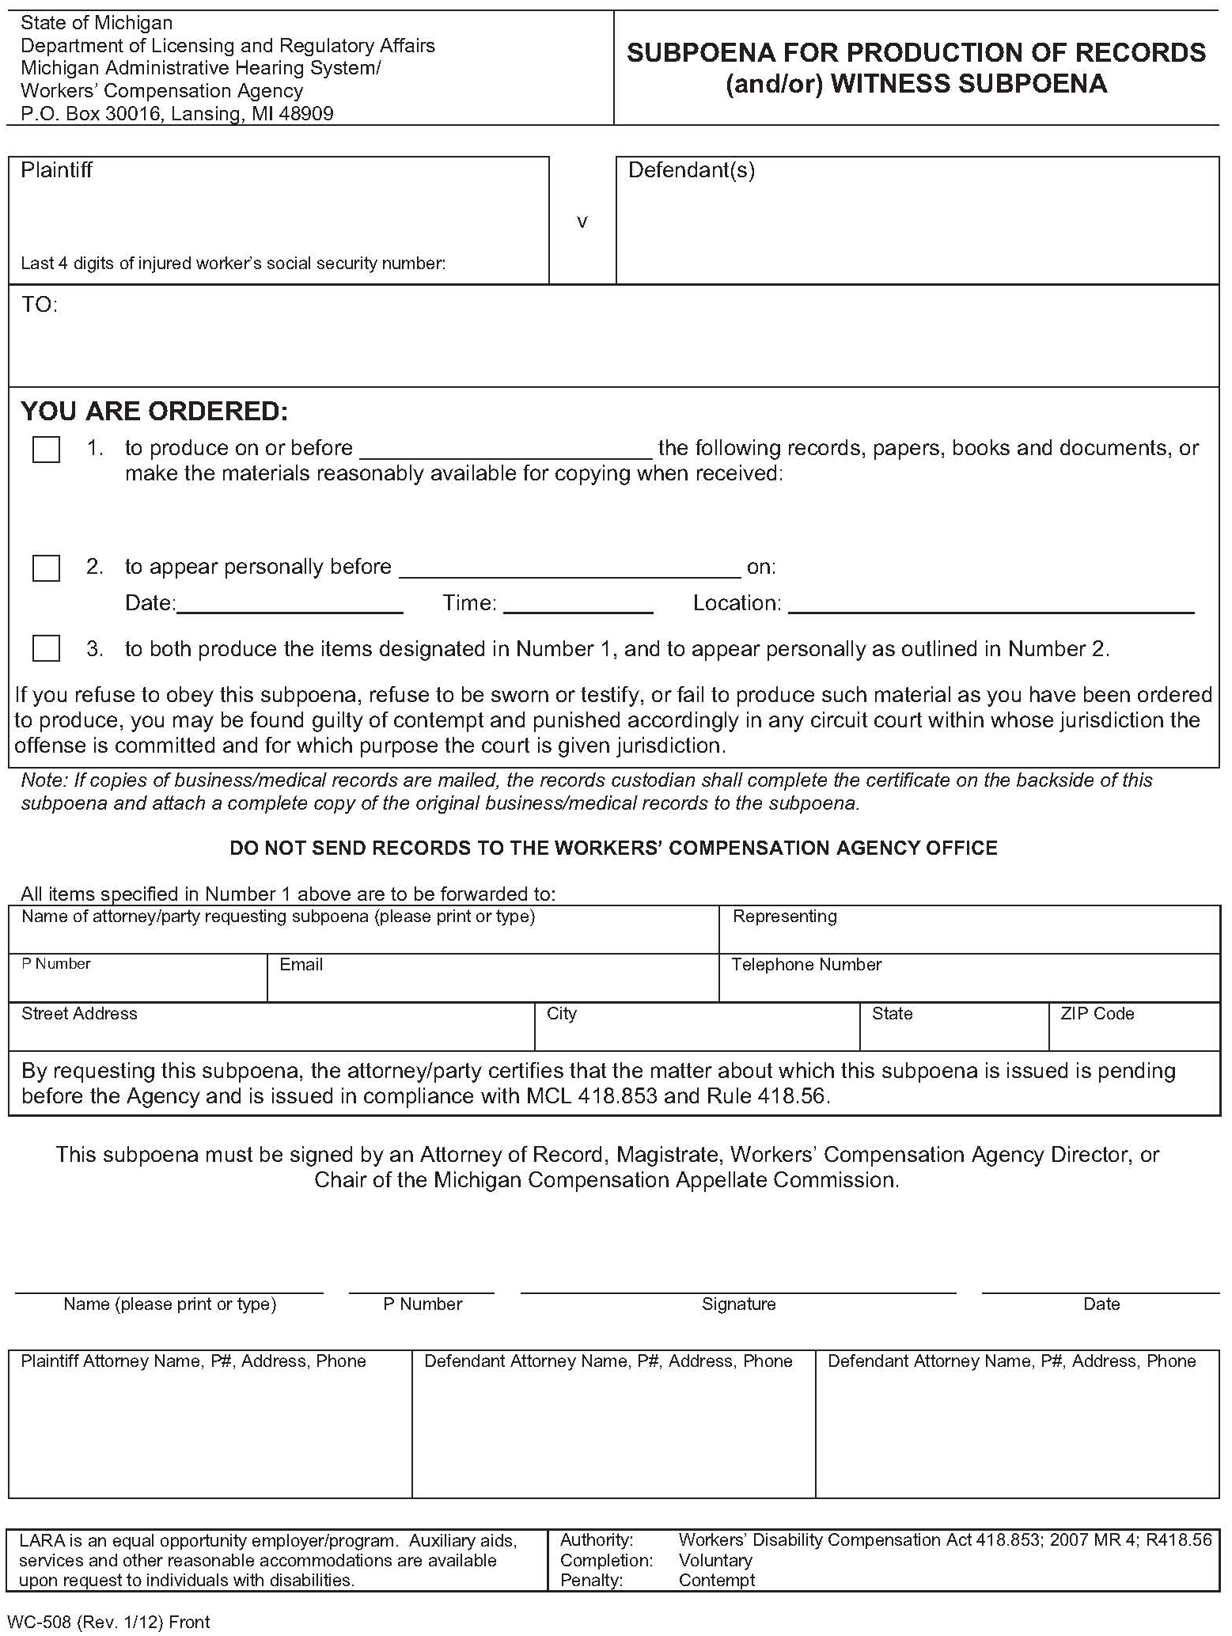
Jocelyn Brooks

xxx-xx-1286
Shirley Davis, Alvin Davis, Taveras
Rodriguez and Aracena's Transport, Inc.

American Transit Insurance Co.
1 Metro Tech Center
Brooklyn, NY 11201

Entire No-Fault file from 6/29/2012 to present pertaining to Jocelyn Brooks SSN: xxx-xx-1286, DOB: 03/08/1968.

X
Jayashri S. Cuffey c/o Axiom Requisition Copy Service
2869 Jolly Road Okemos MI 48864
October 07, 2014ctober 07, 2014
records@axiomcopy.com (877) 886-5090
Jayashri S. Cuffey

Jayashri S. Cuffey ldb
Yuriy Prakhin
Yuriy Prakhin Law Office
1883 86th Street, 2nd Floor
Brooklyn, NY 11214
(718) 946-1782
Jayashri S. Cuffey
Crisci, Weiser & McCarthy
17 State Street, 8th Floor
New York, NY 10004-9992
(212) 943-8940

Order No. 01-28888-001

Order No. 01-28888-001
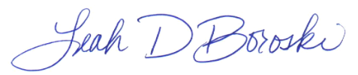
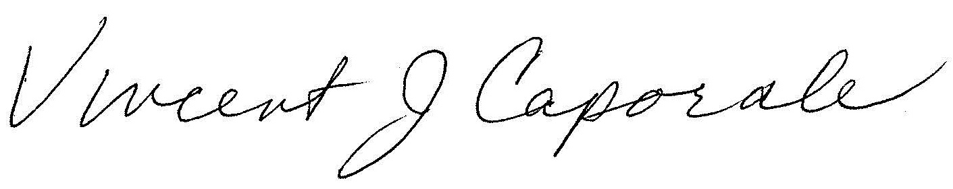
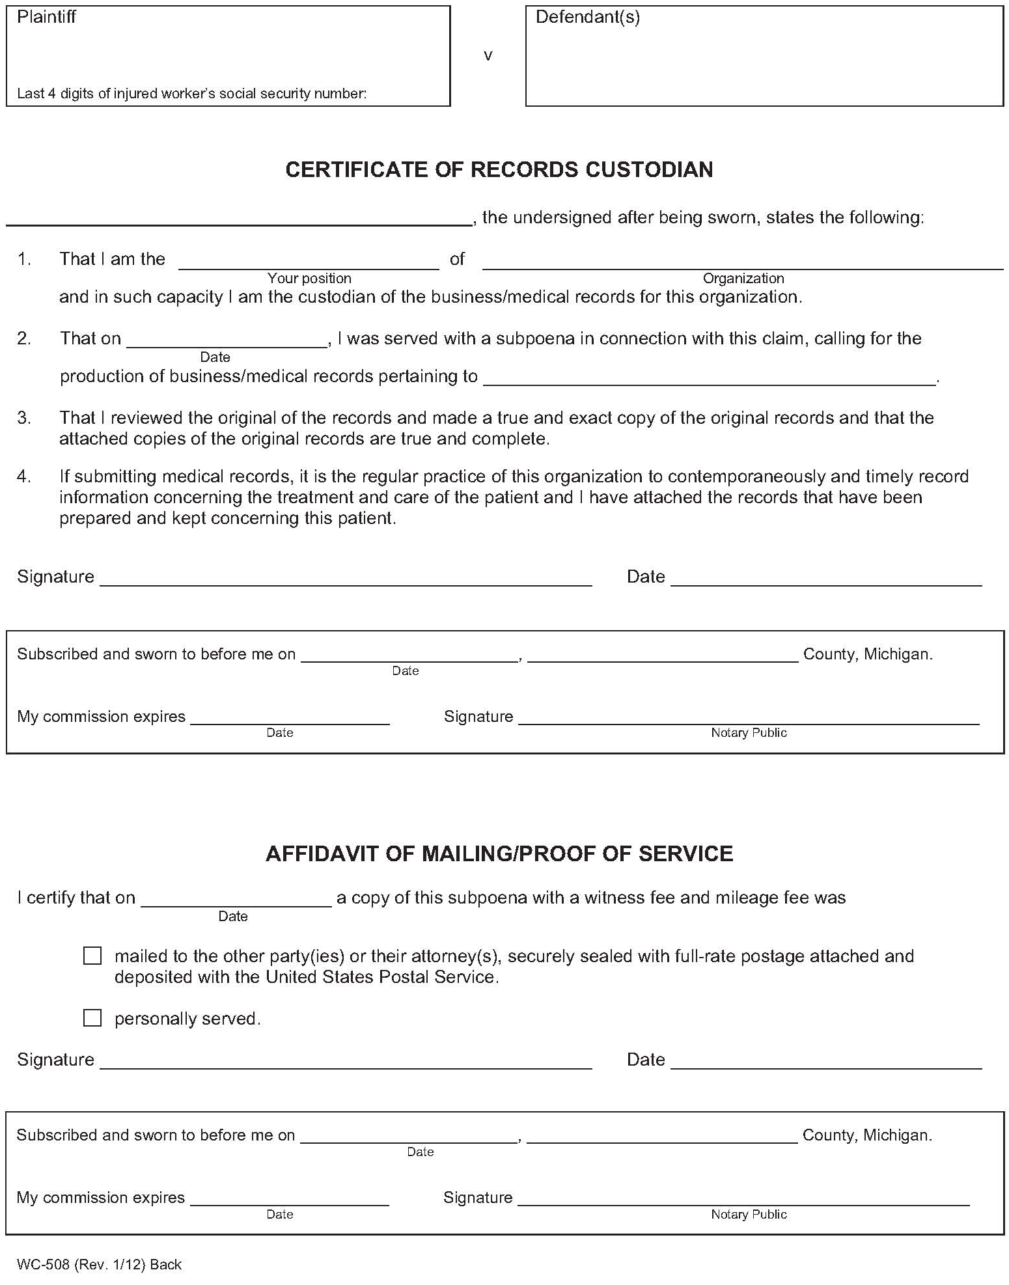
Jocelyn Brooks

xxx-xx-1286
Shirley Davis, Alvin Davis, Taveras
Rodriguez and Aracena's Transport, Inc.

X
11/8/26 Eaton
3/26/2018

